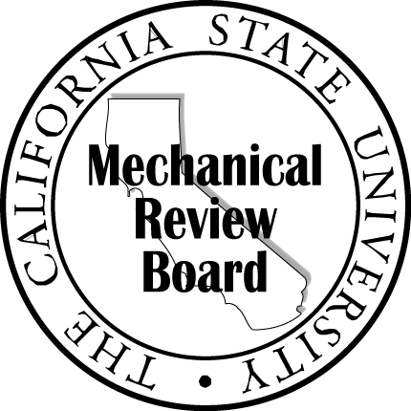

The California State University Mechanical Review Board

[Date]

[Name]
[Title]
[Department]
[Campus]
[Address Line 1]
[Address Line 2]

Subject: [Project] Completion of Mechanical Systems Review

Dear [Campus Project Manager]:

The design review of the mechanical and electrical systems is complete. The review comments have been discussed and resolved between the MSR and ESR reviewers, and the design team.
Please feel free to contact us if you wish to discuss the details of the design review further.

Sincerely,

[Company]

[MRB Member Name]
[Title]

cc: Rachel Patterson, Chancellor’s Office
Ebi Saberi, Chancellor’s Office

